**Assignment 3**

**Anurag Behera**

**2017A8PS0594H**

**Uttam Singh**

**2017A8PS0683H**

**Sequential Learning**

Data set of 160 numbers is generated randomly using np.random.uniform()

Generated dataset has a mean of 0.6699

Distribution of the data

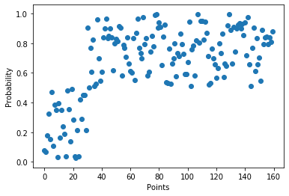

a is generated randomly and b is calculated from a/(a+b) = 0.4 as mentioned in the question

GIF of the prior is included in the zip file  
Plots of prior at Coin 1 to Coin 160 at itervals of 20 is shown below

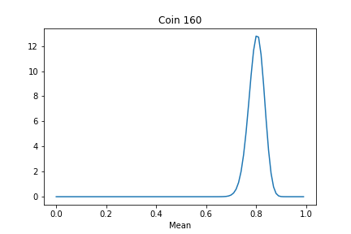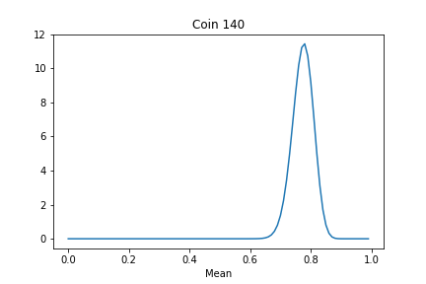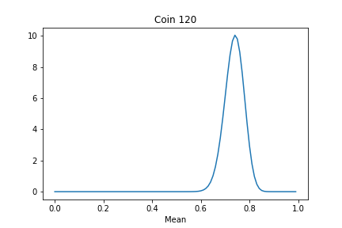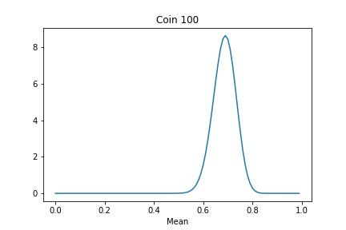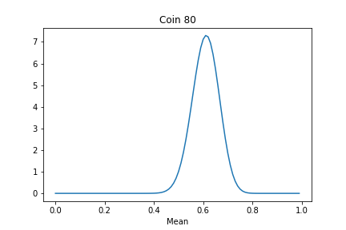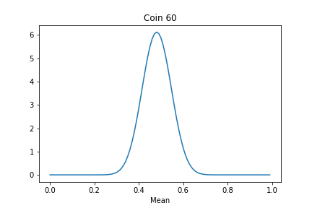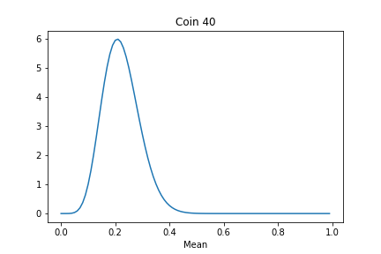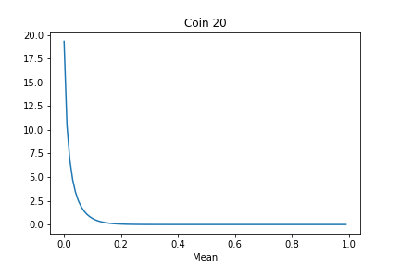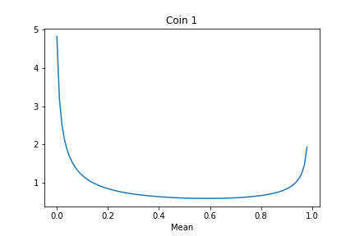

**PART B**

**Plot of Prior**

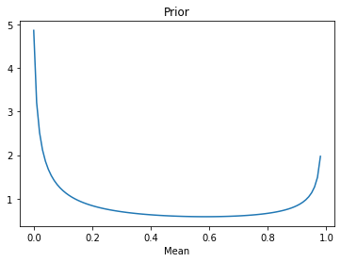

**Plot of Likelihood**

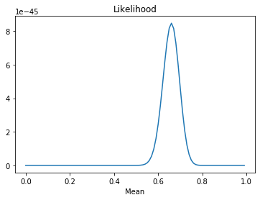

**Plot of Posterior**

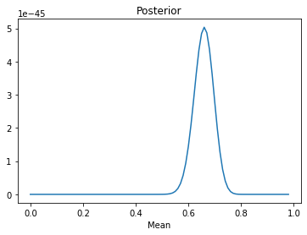

For the randomly generated dataset

Likelihood Value = 8.4763752e-45

Prior Value = 0.44380574

Posterior Value 3.7514849e-46

**PART C**

Data set of 160 numbers is generated randomly using np.random.uniform()

Generated dataset has a mean of 0.507

**Distribution of the data**

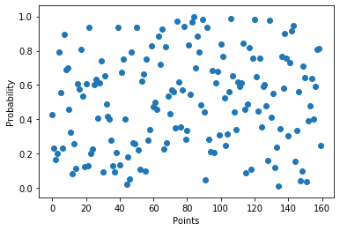

**Prior**

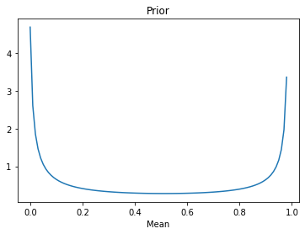

**Likelihood**

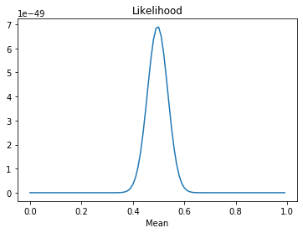

**Posterior**

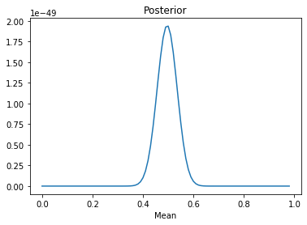

We observe that the posterior probability is max at around 0.5 which is supposed to be the mean of the data. In PART A,B the posteriors centered around 0.7 which was supposed to be the mean of the data that was generated for that problem

Data set of 1600 numbers is generated randomly using np.random.uniform()

Generated dataset has a mean of 0.507

**Prior**

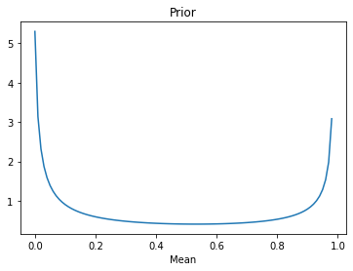

**Likelihood**

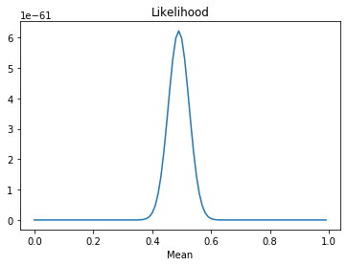

**Posterior**

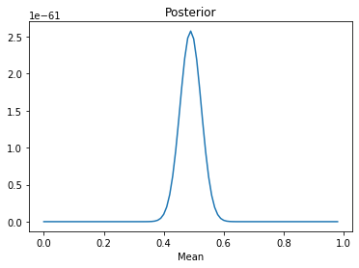

**Comments**

We observe that the plots of posterior center around the mean of the data.

Also increasing the number of data points from 160 to 1600 had little effect on the shape of the posterior, as it centers around mean as mentioned. Although the probability value decreased from 10-49 to 10-61